**Student name:Jeevan Neupane**

**Subject:Calculus I**

**#Answer-1:**

**(a) Find the average velocity over time intervals: In order to compute the average velocity across time intervals, we need to calculate the displacement of rock during each time interval and divide it by interval length.**

**(i) [1, 2]:**

We can find the average velocity from time t = 1 to t = 2, by subtracting the initial position (t = 1) from the final position (t = 2) and dividing it by the time interval (2 - 1 = 1).

Initial position (t = 1): y(1) = 10(1) - 1.86(1^2)

= 10 - 1.86 = 8.14 m

Final position (t = 2): y(2) = 10(2) - 1.86(2^2)

= 20 - 7.44 🡺 12.56 m

Displacement: y(2) - y(1)

= 12.56 - 8.14 🡺 4.42 m

Average velocity: Displacement / Time interval

= 4.42 m / 1 s 🡺 4.42 m/s

**(ii) [1, 1.5]:**

Similarly, for the time interval from t = 1 to t = 1.5:

Initial position (t = 1):

y(1) = 8.14 m (from the previous calculation) Final position (t = 1.5):

y(1.5) = 10(1.5) - 1.86(1.5^2)

= 15 - 4.185 🡺 10.815 m

Displacement: y(1.5) - y(1)

= 10.815 - 8.14 🡺 2.675 m

Average velocity: Displacement / Time interval

= 2.675 m / 0.5 s 🡺 5.35 m/s

**(iii) [1, 1.1]:**

For the time interval from t = 1 to t = 1.1:

Initial position (t = 1): y(1) = 8.14 m (from the previous calculation)

Final position (t = 1.1): y(1.1) = 10(1.1) - 1.86(1.1^2)

= 11 - 2.0466 🡺 8.7494 m

Displacement: y(1.1) - y(1)

= 8.7494 - 8.14 🡺 0.6094 m

Average velocity: Displacement / Time interval

= 0.6094 m / 0.1 s 🡺 6.094 m/s

**(iv) [1, 1.01]:**

For the time interval from t = 1 to t = 1.01:

Initial position (t = 1): y(1) 🡺 8.14 m (from the previous calculation)

Final position (t = 1.01): y(1.01) 🡺 10(1.01) - 1.86(1.01^2)

= 10.1 - 1.8666 🡺 8.2027 m

Displacement: y(1.01) - y(1)

= 8.2027 - 8.14 🡺 0.0627 m

Average velocity: Displacement / Time interval

= 0.0627 m / 0.01 s🡺 6.27 m/s

**(v) [1, 1.001]:**

For the time interval from t = 1 to t = 1.001:

Initial position (t = 1): y(1) = 8.14 m (from the previous calculation)

Final position (t = 1.001): y(1.001) = 10(1.001) - 1.86(1.001^2)

= 10.01 - 1.86603 🡺 8.1463 m

Displacement: y(1.001) - y(1) = 8.1463 - 8.14 = 0.0063 m

Average velocity: Displacement / Time interval = 0.0063 m / 0.001 s = 6.3 m/s

**#Answer-1b):**

**Estimate the instantaneous velocity in Excel when** 𝑡 **= 1:**

**#Answer-2a):**

**(a) Find the average velocity during each time period:**

Here, Given:

𝑠 = 2sin (𝜋𝑡) + 3cos (𝜋𝑡)

**(i) [1, 2]** At t=1, s (1) = 2 sin (𝜋*1) + 3 cos (𝜋*1) s (1) = 2 sin (𝜋) + 3 cos (𝜋) s (1) = 2 (0) + 3 (-1) s (1) = -3 cm

At t=2, s (2) = 2 sin (𝜋*2) + 3 cos (𝜋*2) s (2) = 2 sin (2𝜋) + 3 cos (2𝜋) s (2) = 2 (0) + 3 (1) s (2) = 3 cm

Displacement during the interval is,

Δs = s (2) -s (1) Δs = 3-(-3)

Δs = 6cm

The time duration of the interval (Δt) is 2-1=1 sec.

So, average velocity= Δs/Δt

= 6/1 🡺6 cm/s

**(ii) [1, 1.1]** At t=1, s (1) = -3 cm

At t=1.1,

s (1.1) = 2 sin (𝜋*1.1) + 3 cos (𝜋*1.1) s (1.1) = 2 sin (1.1𝜋) + 3 cos (1.1𝜋) s (1.1) = -3.4712 cm

Displacement during the interval is,

Δs = s (1.1) -s (1)

Δs = -3.4712- (-3)

Δs = -0.4712 cm

The time duration of the interval (Δt) is (1.1)-1=0.1 sec.

So, average velocity= Δs/Δt

= -0.4712/0.1 🡺 -4.712 cm/s

**(iii) [1, 1.01]** At t=1, s (1) = -3 cm

At t=1.01, s (1.01) = 2 sin (𝜋*1.01) + 3 cos (𝜋*1.01) s (1.01) = 2 sin (1.01𝜋) + 3 cos (1.01𝜋) s (1.01) = -3.06134 cm

Displacement during the interval is,

Δs = s (1.01) -s (1)

Δs = -3.06134- (-3)

Δs = -0.06134 cm

The time duration of the interval (Δt) is (1.01)-1=0.01 sec. So, average velocity= Δs/Δt

= -0.06134/0.01 🡺 -6.134 cm/s

**(iv) [1, 1.001]** At t=1, s (1) = -3 cm

At t=1.001, s (1.001) = 2 sin (𝜋*1.001) + 3 cos (𝜋*1.001) s (1.001) = 2 sin (1.001𝜋) + 3 cos (1.001𝜋) s (1.001) = -3.006268 cm

Displacement during the interval is,

Δs = s (1.001) -s (1)

Δs = -3.006268- (-3)

Δs = -0.006268 cm

The time duration of the interval (Δt) is (1.001)-1=0.001 sec.

So, average velocity= Δs/Δt

= -0.006268/0.001

=-6.268 m/s

**Answer-2b):**

**#Answer-3a)**

Here we can see that (0/0) is indeterminate from now we can apply the L’hospital rule.

L=== 𝑥limlim→→ 0 𝑠𝑖𝑛𝑠𝑖𝑛𝑑 (𝑠𝑖𝑛𝑥(𝜋𝑥𝑥))

𝑐𝑜𝑠 1π1 𝑐𝑜𝑠 π

===0.32π𝑥 ×𝑐𝑜𝑠[(0𝑐𝑜𝑠𝜋( 𝑥1𝑥))𝑑𝑥((.𝑑𝜋=00))𝑠𝑖𝑛𝑑𝑥]1(𝜋𝑥).𝜋

Answer-3b)

**Answer-4a):**

=e=2.71=[= 𝑥lim→𝑥lim0→[1+1+0 (11! ++1𝑥)(3111𝑥2!−! 𝑥+) 𝑥412! ++……………] 1−(1−𝑥3)!(1−2𝑥) 𝑥3 + .] 1 + 1 + 2

Using the binomial expression function, we get:

(1 + 𝑥)𝑛 = 1 + 𝑛𝑥 + 𝑛(𝑛2−! 1) 𝑥2 + 𝑛(𝑛−13)!(𝑛−2) 𝑥3 + .

**#Answer-4b)**

**#Answer-5a)**

**#Answer-5b)**

To get a graph that represents the function better, we can specify the domain over the range of 3.8 ≤ x ≤ 4.15 as shown below.

**Answer-6a)**

𝑥lim→ 1 𝑥3~~𝑥~~ −− 11

⇒⇒ 𝑥lim →𝑥lim→1 1(𝑥𝑥−3(~~𝑥~~ −1−~~𝑥~~) 11(+𝑥12+)(𝑥1~~𝑥~~)( +1~~𝑥~~) +1)

⇒𝑥lim→ 1 (𝑥 − 1)(𝑥(2+~~𝑥~~)𝑥2+ +11)( ~~𝑥~~ +1)

⇒𝑥lim→ 1 (𝑥 − 1)(𝑥2𝑥+ −𝑥+11)( ~~𝑥~~ +1)

⇒ 𝑥lim→ 1 𝑥2 + 𝑥 + 1)( 𝑥 + 1)

⇒⇒⇒(3*2612 + 1 + 1)(1 + 1)

⇒⇒6𝑥lim→ 1 𝑥3~~𝑥~~ −− 11

**#Answer-6b)**

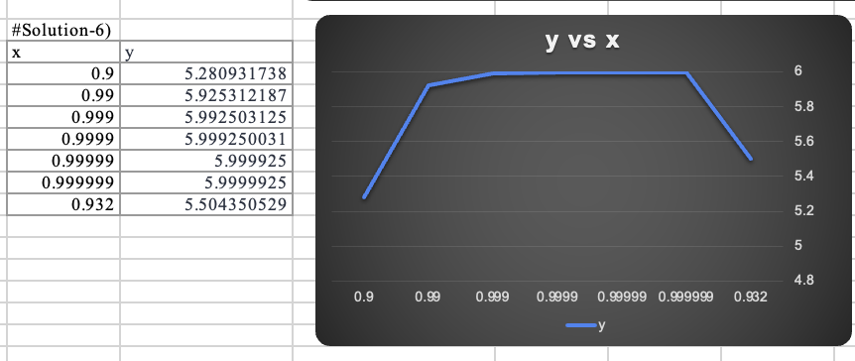

From the graph, we can see that x should be approx. 0.932, if they are away from the limit at 0.5.